UN Commission on Science and Technology for Development: Recommendations on Gender, Science and Technology.

Report from the World Association for Sustainable Development 4th Conference, Naples, 6-8 Nov 2006

by

Elyse Ruest-Archambault, M.Eng, M.Sc.
SPRU (Science and Technology Policy Research)
University of Sussex
Freeman Centre, Falmer
Brighton, East Sussex BN1 9QE
United Kingdom
<elyser@gmail.com>

During the workshop on Gender Science and Development at the World Association for Sustainable Development’s 4th Conference (2006), a panel, chaired by Professor Geoffrey Oldham, reviewed the recommendations on Gender and Science made 11 years ago by the UN Commission on Science and Technology for Development and highlighted the following matters:

- The 1995 Gender Working Group’s conclusions and recommendations (Gender Working Group of the United Nations Commission on Science and Technology for Development 1995) are still valid 11 years later and accurately encompass today’s issues.

- Data from Europe and USA show that women are still largely under-represented in science [1].

- Data show that women choose different fields and subjects of science than men [2].

- Data indicate that equal opportunity measures such as targets and quotas are desirable to achieve equal representation of women in science [3].

- The incompatibility between ‘masculine’ science and ‘feminine’ women needs further addressing [4].

Following the discussion from the panel, and in order to solve the previously mentioned issues, the following recommendations are proposed:

- Implementation of 40:40% targets for women and mens representation in science bodies (e.g. Universities –at student/ PhD/ researcher/ professor levels-, Research Centres, Academies, UN agencies in science and technology) [5].

- Set up of a mass information campaign tailored to each country’s reality and aimed at highlighting the national inequalities as well as adjusting the cultural division of labour that inhibits women’s equal participation in science [6].

- Continuation of the collection of sex-segregated data, particularly from developing countries [7].

Footnotes

[1] See Annexe 1.
Although the data in Tables 1-5 show that the proportion of women PhD graduates has been increasing constantly since 1998 in the studied countries, the numbers indicate that the participation of women in science is not nearly equal to that of men.

[2] See Annexes 1 and 2.
Tables 1-5 and Figures 2-5 illustrate particularly well the difference between women’s and men’s choices of studies (or the ‘horizontal’ segregation that exists between the different fields of science). In the EU15, in 2004, women represented 51.5% of PhD graduates in Agriculture and veterinary while they represented only 22.9% of Engineering manufacturing and construction PhD graduates. Women are therefore more highly represented (i.e. chose to study) in the more ‘feminine’ (or ‘human’ or ‘social’) branches of science.

[3] When comparing the characteristics of each country’s policies, it emerges that the UK and Italy are using numerical targets and positive action measures whereas the USA is avoiding them. The fact that in Italy women are more equally represented in science that in the UK and the USA indicates that equal opportunity measures such as targets and quotas are efficient to increase women’s participation in science (Ruest-Archambault 2006).

[4] Science is perceived as masculine both in its theory as well as its practice and culture (Benston 1992; Birke 1994; Maynard 1997; Arnot et al. 1999). As Fox Keller illustrates, “To learn to be a scientist is to learn the attributes of what culture calls masculinity” (1992:47). Classics such as Emanuel Kant (cited in Schiebinger, 1989:271) wrote about woman: “her philosophy is not to reason, but to sense”. Women are expected to be ‘feminine’, which is to say sensible, caring, graceful, cooperative and nurturing, while men are supposed to be ‘masculine’ (i.e. competitive, authoritarian, rational) (Schiebinger 1989). Under this concept, what is female is ‘unlimited’, ‘curved’, ‘dark’ and ‘bad’, as opposed, on the male side, to ‘limited’, ‘straight’, ‘light’, and ‘good’. All these feminine qualities are deemed to be undesirable in science, which is supposedly objective, rational and rigorous.

[5] The European Commission has implemented a target of “40% participation of women at all levels in implementing and managing research programmes” (Commission of the European Community 2005:3). Many of the member countries of the European Union have implemented quotas or targets in university/ research institute committees (see Figure 1 below). The UN and its member countries, similarly, should implement the 40% women targets.

Figure 1: Summary chart of Equality Measures in Europe
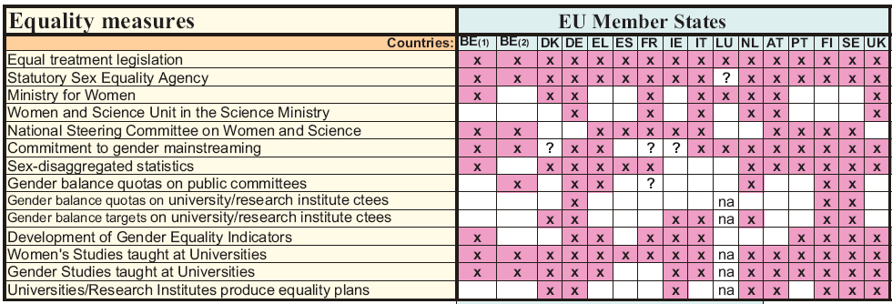

Source: Rees (2002:32)

[6] There is a need to raise awareness of the present inequalities in women’s representation in science as well as in women’s image in society. For example, the United Kingdom Resource Centre for Women in Science, Engineering and Technology works to change the image of women in TV dramas and launched a role model poster campaign (UKRC 2003).

[7] Although there has been an improvement in the availability of sex-segregated data in the last 11 years, particularly in Europe and North America, in most countries data on women in science is still unavailable. For example, the UN Gender Advisory Board website refers to only one site which contains some data from developing countries (http://gstgateway.wigsat.org/TA/datacareers.shtml).

References

Arnot, M., David, M. and Weiner, G. (1999) Closing the Gender Gap: Postwar Education and Social Change, Cambridge: Polity Press.

Benston (1992) Women’s voices/ Men’s voices: Technology as Language, in Kirkup, G. and Smith Keller, L. ed (1992), Inventing Women, Science, Technology and Gender, Polity/Open University, Cambridge.

Birke, L. (1994) Interventions in hostile territory, in Griffins, G., Hester, M., Rai, S. and Roseneil, S. (Eds.) Stirring It: Challenges for Feminism, London Taylor & Francis

Commission of the European Community (2005) Women and Science: Excellence and Innovation - Gender Equality in Science, Commission Staff Working Document, Internet, http://europa.eu.int/comm/research/science-society/pdf/documents_women_sec_en.pdf, Accessed on 14/11/05

European Commission (2003) She Figures 2003, Women and Science, Statistics and Indicators, European Communities, Brussels

European Commission (2006) She Figures 2006, Women and Science, Statistics and Indicators, European Communities, online, http://ec.europa.eu/research/science-society/women/wssi/publications_en.html, accessed 09/06/06.

Fox Keller, E. (1992) How Gender Matters, or, Why it’s so Hard for us to Count Past Two, in Kirkup, G. and Smith Keller, L. ed (1992), Inventing Women, Science, Technology and Gender, Polity/Open University, Cambridge.

Gender Working Group of the United Nations Commission on Science and Technology for Development (1995) Missing Links, Gender Equity in Science and Technology for Development, IDRC/ITDG Publishing/UNIFEM, available online http://www.idrc.ca/en/ev-9359-201-1-DO_TOPIC.html#begining, accessed 24/11/06

Maynard, M. ed. (1997) Science and the Construction of Women, UCL Press, London

Naldi, F. and Parenti, I. V. (2002) Biosoft sas: Bibliometric and Patent Indicators by Gender: Two Feasibility Studies. Vol. 1. Statistics online http://www.cordis.lu/indicators/publications.htm accessed 20/06/06

Rees, T (2002) The Helsinki Group on Women in Science: National Policies on
Women in Science in Europe, Brussells: European Commission.

Ruest-Archambault, E. (2006) Science Policies for Sustainable Women Participation in Science: A Cross-Country Comparison, Unpublished M.Sc. thesis, Science Policy Research Unit, University of Sussex.

Schiebinger, L. (1989) The Mind Has No Sex? Women in the Origins of Modern Science, Harvard University Press, London

UKRC (2003) SETting the standard, online http://extra.shu.ac.uk/nrc/section_0/UKRC%20Strategy%20Guide.pdf, page 13, accessed 27/11/06

US Patent & Trademark Office (1999) Buttons to Biotech, 1996 Update Report with supplemental data through 1998, online http://www.uspto.gov/web/offices/ac/ido/oeip/taf/wom_98.pdf accessed 20/06/06
Annexe 1

1- PhD graduates

Table 1: Number of PhDs* obtained by women in Social sciences, business and law**:
 |  | 1998 | 1999 | 2000 | 2001 | 2002 | 2003 | 2004
EU15 | Total | 11489 | 11442 | 11765 | 12377 | 12428 | 13222 | 14350
EU15 | Female | 4278 | 4330 | 4617 | 4860 | 5085 | 5648 | 6369
EU15 | %Fem. | 37.2 | 37.8 | 39.2 | 39.3 | 40.9 | 42.7 | 44.4
Italy | Total | 725 | 599 | 670 | 631 | 730 | 1128 | 1128
Italy | Female | 360 | 320 | 308 | 300 | 355 | 568 | 568
Italy | %Fem. | 49.7 | 53.4 | 46.0 | 47.5 | 48.6 | 50.4 | 50.4
UK | Total | 1563 | 1868 | 1552 | 1807 | 1818 | 1980 | 2609
UK | Female | 582 | 752 | 629 | 726 | 751 | 836 | 1324
UK | %Fem. | 37.2 | 40.3 | 40.5 | 40.2 | 41.3 | 42.2 | 50.7
USA | Total | 4055 | 4064 | 4156 | 4078 | 4004 | 4142 | 4131
USA | Female | 1684 | 1696 | 1784 | 1750 | 1781 | 1848 | 1817
USA | %Fem. | 41.5 | 41.7 | 42.9 | 42.9 | 44.5 | 44.6 | 44.0
* For UK and Italy: numbers of ISCED 6 obtained
**For USA: the numbers only include the same Social Sciences as Europe (Economics, Political Science, Sociology, Geography, History) but not Business nor Law.
Source: compiled from NSF S&E Doctorate Awards and Eurostat Population and social conditions: Enrolments, graduates, entrants, personnel and language learning

Table 2: Number of PhDs* obtained by women in Engineering, manufacturing, construction**:
 |  | 1998 | 1999 | 2000 | 2001 | 2002 | 2003 | 2004
EU15 | Total | 9142 | 9523 | 9186 | 9584 | 9659 | 10065 | 10492
EU15 | Female | 1622 | 1857 | 1849 | 1971 | 2029 | 2166 | 2405
EU15 | %Fem. | 17.7 | 19.5 | 20.1 | 20.6 | 21.0 | 21.5 | 22.9
Italy | Total | 762 | 717 | 808 | 738 | 853 | 1177 | 1177
Italy | Female | 253 | 251 | 278 | 265 | 283 | 367 | 367
Italy | %Fem. | 33.2 | 35.0 | 34.4 | 35.9 | 33.2 | 31.2 | 31.2
UK | Total | 1997 | 1966 | 1847 | 2190 | 2021 | 2239 | 2218
UK | Female | 325 | 349 | 360 | 412 | 382 | 439 | 471
UK | %Fem. | 16.3 | 17.8 | 19.5 | 18.8 | 18.9 | 19.6 | 21.2
USA | Total | 5924 | 5330 | 5321 | 5505 | 5076 | 5278 | 5776
USA | Female | 774 | 788 | 837 | 929 | 888 | 896 | 1014
USA | %Fem. | 13.1 | 14.8 | 15.7 | 16.9 | 17.5 | 17.0 | 17.6
* For UK and Italy: numbers of ISCED 6 obtained
**For USA: engineering only
Source: compiled from NSF S&E Doctorate Awards and Eurostat Population and social conditions: Enrolments, graduates, entrants, personnel and language learning

Table 3: Number of PhDs* obtained by women in Agriculture and veterinary**:
 |  | 1998 | 1999 | 2000 | 2001 | 2002 | 2003 | 2004
EU15 | Total | 2780 | 2593 | 2533 | 2493 | 2599 | 2663 | 2739
EU15 | Female | 1192 | 1191 | 1154 | 1155 | 1286 | 1344 | 1411
EU15 | %Fem. | 42.9 | 45.9 | 45.6 | 46.3 | 49.5 | 50.5 | 51.5
Italy | Total | 355 | 209 | 350 | 342 | 306 | 384 | 384
Italy | Female | 207 | 119 | 196 | 190 | 170 | 209 | 209
Italy | %Fem. | 58.3 | 56.9 | 56.0 | 55.6 | 55.6 | 54.4 | 54.4
UK | Total | 397 | 331 | 349 | 341 | 339 | 301 | 318
UK | Female | 138 | 120 | 130 | 135 | 145 | 136 | 150
UK | %Fem. | 34.8 | 36.3 | 37.2 | 39.6 | 42.8 | 45.2 | 47.2
USA | Total | 1110 | 1065 | 1038 | 975 | 1009 | 1061 | 1046
USA | Female | 328 | 311 | 317 | 339 | 318 | 370 | 398
USA | %Fem. | 29.5 | 29.2 | 30.5 | 34.8 | 31.5 | 34.9 | 38.0
* For UK and Italy: numbers of ISCED 6 obtained
**For USA : agricultural sciences
Source: compiled from NSF S&E Doctorate Awards and Eurostat Population and social conditions: Enrolments, graduates, entrants, personnel and language learning

Table 4: Number of PhDs* obtained by women in Total S&E**:
 |  | 1998 | 1999 | 2000 | 2001 | 2002 | 2003 | 2004
EU15 | Total | 45250 | 45084 | 45897 | 47572 | 48182 | 49222 | 51611
EU15 | Female | 14372 | 14740 | 15449 | 16251 | 17373 | 18334 | 19426
EU15 | %Fem. | 31.8 | 32.7 | 33.7 | 34.2 | 36.1 | 37.2 | 37.6
Italy | Total | 2518 | 2284 | 2649 | 2529 | 3196 | 4620 | 4620
Italy | Female | 1146 | 1048 | 1174 | 1159 | 1518 | 2187 | 2187
Italy | %Fem. | 45.5 | 45.9 | 44.3 | 45.8 | 47.5 | 47.3 | 47.3
UK | Total | 7806 | 8006 | 8013 | 9540 | 9381 | 9772 | 9988
UK | Female | 2315 | 2576 | 2709 | 3298 | 3439 | 3613 | 3781
UK | %Fem. | 29.7 | 32.2 | 33.8 | 34.6 | 36.7 | 37.0 | 37.9
USA | Total | 27278 | 25933 | 25966 | 25548 | 24588 | 25289 | 26275
USA | Female | 9349 | 9082 | 9393 | 9331 | 9159 | 9477 | 9819
USA | %Fem. | 34.3 | 35.0 | 36.2 | 36.5 | 37.2 | 37.5 | 37.4
* For UK and Italy: numbers of ISCED 6 obtained
**Europe: S&E = Agriculture and veterinary, Engineering, manufacturing and construction, Science, mathematics and computing, Social sciences, business and law. For the USA, S& E include Computer and information science, Mathematics, Life and related science, Physics, Social science, Psychology and all Engineering
Source: compiled from NSF S&E Doctorate Awards and Eurostat Population and social conditions: Enrolments, graduates, entrants, personnel and language learning.

2- Professors

Table 5: Female S&E University Professors*
 |  | Engineering** |  |  |  | Science*** |  |  |  | S&E
 |  | 2001 | 2002 | 2003 | 2004 | 2001 | 2002 | 2003 | 2004 | 2001 | 2002 | 2003 | 2004
UK | Total |  | 2039 |  | 1679 |  | 8598 |  | 8697 |  | 10637 |  | 10376
UK | Female |  | 99 |  | 83 |  | 1103 |  | 1386 |  | 1202 |  | 1469
UK | %Fem. |  | 4.9 |  | 4.9 |  | 12.8 |  | 15.9 |  | 11.3 |  | 14.2
Italy | Total |  | 2493 |  | 2712 |  | 9860 |  | 11627 |  | 12353 |  | 14339
Italy | Female |  | 129 |  | 165 |  | 1301 |  | 1712 |  | 1430 |  | 1877
Italy | %Fem. |  | 5.2 |  | 6.1 |  | 13.2 |  | 14.7 |  | 11.6 |  | 13.1
USA | Total | 16800 |  | 17200 |  | 104200 |  | 109500 |  | 121000 |  | 126700
USA | Female | 900 |  | 1100 |  | 24100 |  | 26400 |  | 25000 |  | 27500
USA | %Fem. | 5.4 |  | 6.4 |  | 23.1 |  | 24.1 |  | 20.7 |  | 21.7
* For USA, Professor refers to ‘Full-time senior faculty’ S&E doctorate holders. For Italy and UK it is GRADE A professors (like full professors).
**For UK and Italy, Engineering means Engineering & Technology; for USA, it means Engineering.
*** For UK and Italy, Science means Natural Sciences, Medical Sciences, Agricultural Sciences and Social sciences. For USA it means Physical Sciences, Earth/Atmospheric/Ocean Sciences, Mathematics and Computer Sciences, and Social Sciences.
Source: compiled from NSF Science and Engineering Indicators 2006 and European Commission 2003c and 2006.
3- Output

Figure 2: Percentage of women inventors in 1998, by country.

Source: * compiled with data from the US Patent & Trademark Office (1999)
** compiled with data from Naldi and Parent. (2002)

Figure 3: Number of authors of scientific publications by gender and country in 1998.
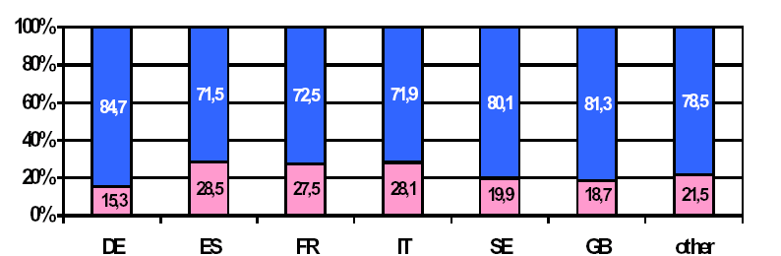

Men

Women

Source: Naldi and Parenti (2002:13), Figure 1

Annexe 2

Figure 4: Authors of scientific publications by gender and discipline, in Europe*, in 1998.

Men

Women

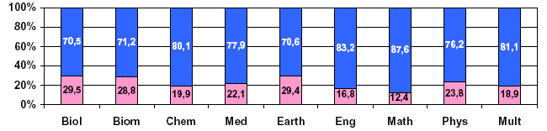

* Europe means UK, France, Germany, Italy, Spain, and Sweden.
Source: Naldi and Parenti (2002:14), Figure 2

Figure 5: Women-Inventor Patents by Technology, 1977-1996 Grants of U.S. Origin.
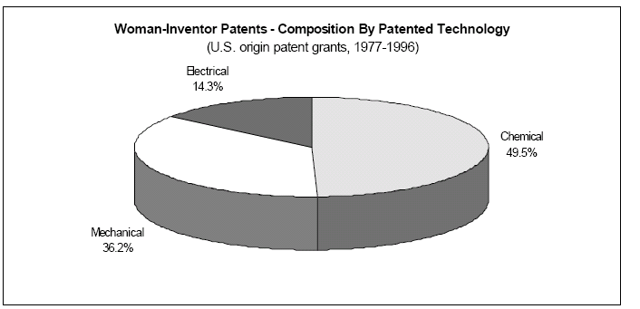

Source: US Patent & Trademark Office (1999:12), Figure 5

